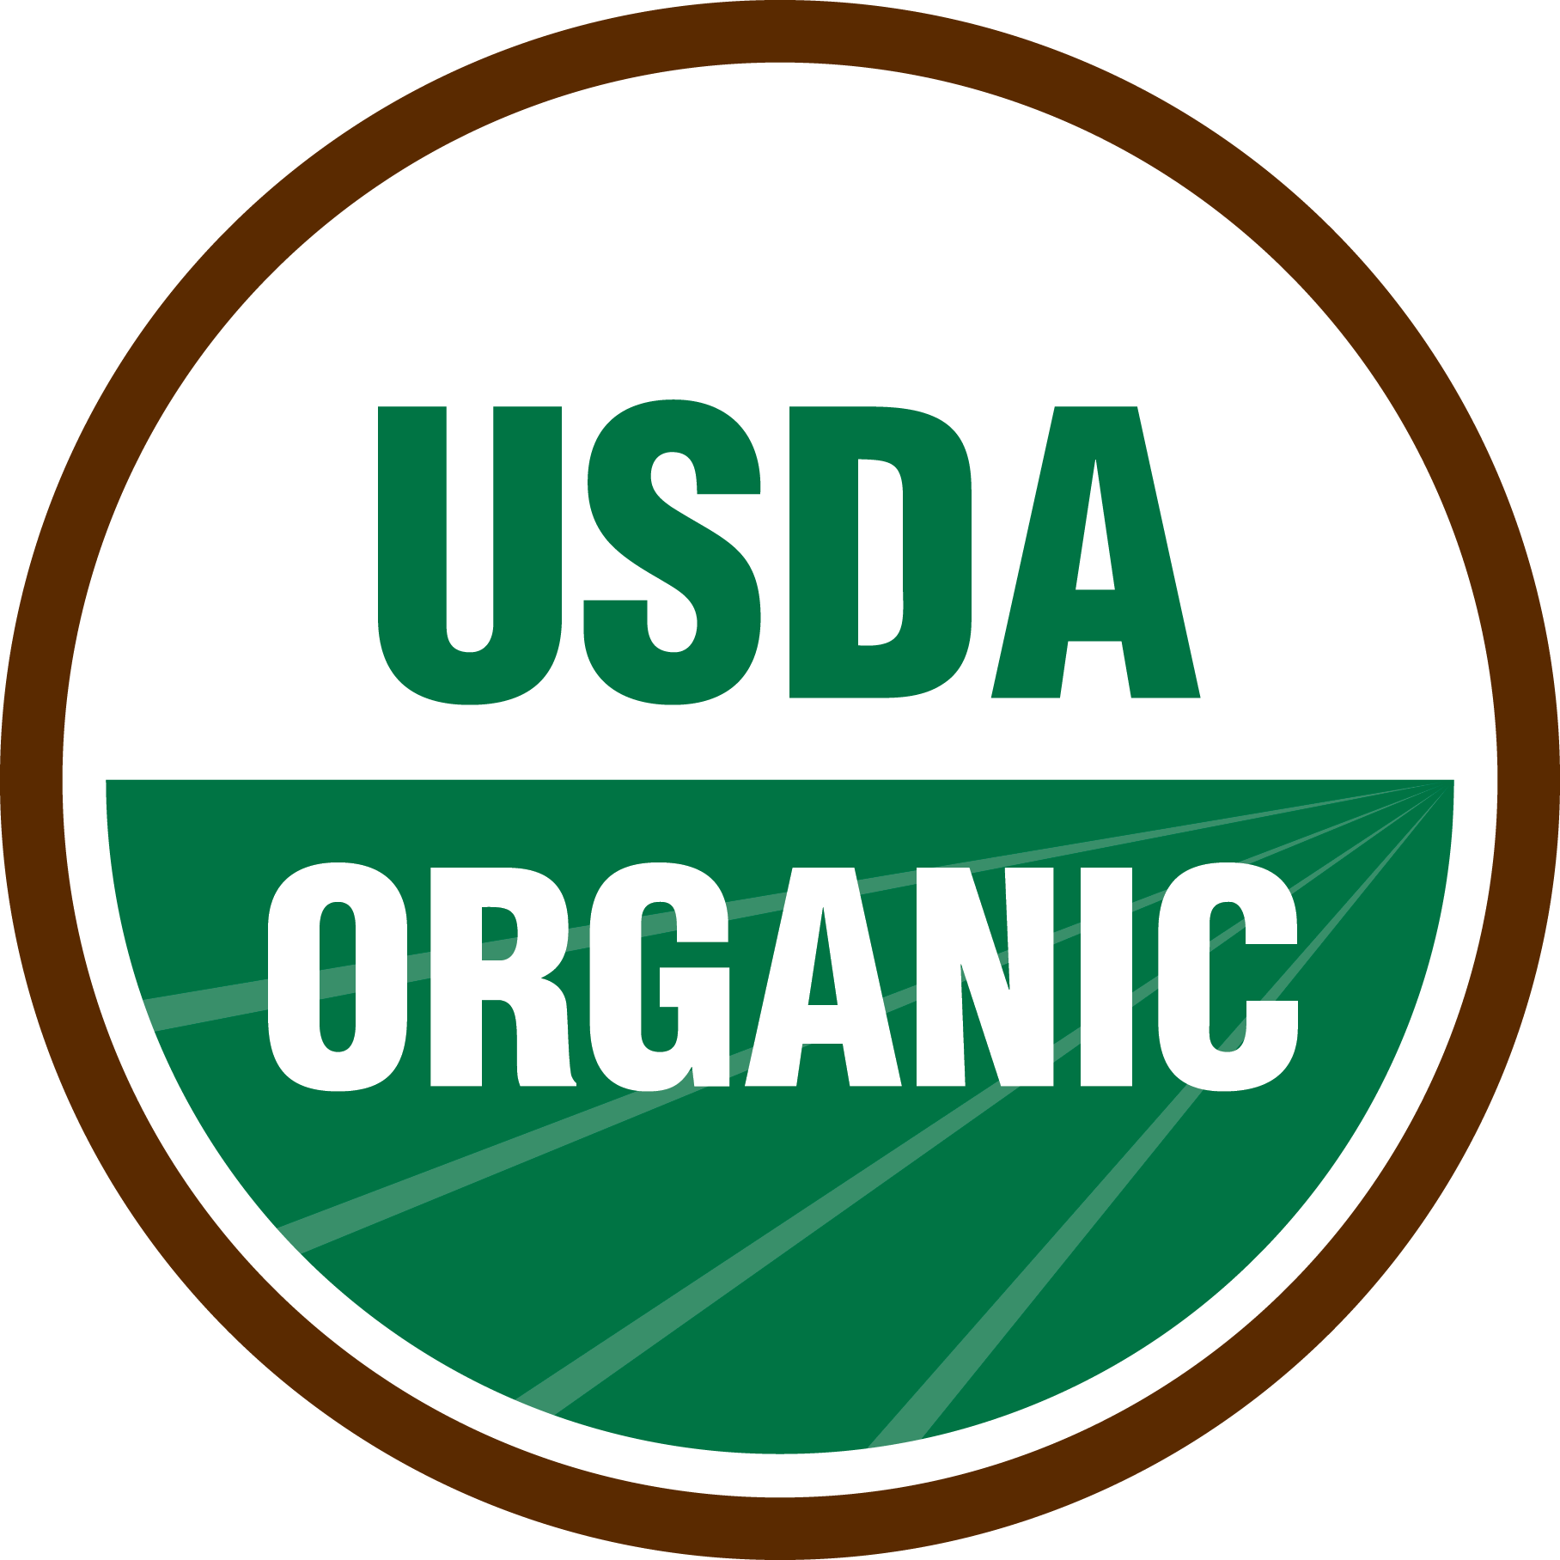
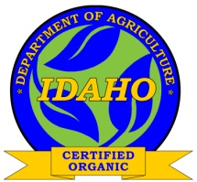
ISDA Private Label Annual Application

The National Organic Program allows for “Private Label” arrangements on organic labels and packaging. Approval for these situations and instruction to accredited certification agents and certified entities can be found in the NOP Handbook, section G, Policy Memos, “PM 11-7; 10/31/2011.”

A private label arrangement arises when an ISDA certified operation wishes to use labeling or packaging for organic products that does not include their name (the name of the ISDA certified entity) and the name of another “distributor” is used. The distributor who is listed on the label may or may not be certified themselves.

Per IDAPA 02.06.33.300 – Organic Food Products Rules, Certification Requirements and Fees [04. Additional Services/Charges. (a.) Private Label Arrangement]: There is an “annual fee of two hundred dollars ($200) per arrangement assessed to ISDA certified co-packer or handler packaging and/or affixing a private label for a non-ISDA certified entity.”

Please provide a complete list below of all private label arrangements your operation currently has with other distributors for which you label or repack and attach a copy of each Private Label Arrangement Form held with each individual entity.

ISDA Certified Entity Information

Company/Business Name:

Primary Organic Contact Name:

Mailing Address: | City: | State: | Zip:
Physical Address: | City: | State: | Zip:
Telephone Number: | Email:

Private Label Arrangement(s) List:

1. |  | 9.
2. |  | 10.
3. |  | 11.
4. |  | 12.
5. |  | 13.
6. |  | 14.
7. |  | 15.
8. |  | 16.
*If your facility handles more than 16 Private Label Arrangements, please attach a complete list to this application.
Fees

Please enclose the appropriate fees as indicated below, per IDAPA 02.06.33 – Organic Food Products Rules. The application will not be processed if the appropriate fees are not included with the application.

Total Number of Arrangements | Fee Per Arrangement | Total Fee Due
 | $200 | $

Affirmation and Signature

By completing this annual Private Label Annual Application, I affirm I am an authorized representative of the certified operation, and I am only providing the service of private labeling for the entities listed on this document. Additionally, I will be responsible to ensure that all products that I label will be compliant with all labeling requirements as specified by the attached Private Label Agreement Forms. I understand that failure to comply with all appropriate standards with regards to the Private Label Agreement(s) may adversely affect my certification with ISDA.

By signing this document, I acknowledge the information on this form and associated attachments is complete and accurate to the best of my knowledge. Furthermore, I understand that I will be responsible for all appropriate fees to be paid to ISDA for all private label arrangements our operation has in place with other distributors for which we label or repack.

ISDA Certified Entity

Title/Company

Signature Date (M/D/Y)

