Enhanced In-Season Nitrogen, Pest, and Irrigation Management for XXXXX Potato Cropping Systems.
PROJECT #8 TITLE
DURATION OF PROJECT

Start Date:
10/1/2022
End Date:
09/29/2024

PROJECT SUMMARY

XXXXX State University is seeking funding to support the project entitled Enhanced In-Season Nitrogen, Pest, and Irrigation Management for XXXXX Potato Cropping Systems. Specifically, this project will improve the competitiveness of XXXXX agronomists and potato growers by developing and implementing technology-based methods to improve in-season potato crop pest sampling, tissue sampling and soil moisture measurement practices in XXXXX and subsequent data interpretations that drive in-season agronomic recommendations to improve environmental and economic sustainability outcomes. Currently, practices are primarily driven by a given agronomist’s experience and general observations, known history of production fields, and other factors that are difficult to quantify. However, new data resources (i.e. ever-expanding and publicly available earth observation satellites) and digital tools exist that could be used to improve agronomic data collection practices and data interpretation. Working with industrial stakeholders, this project aims to develop and implement data collection, analysis, and visualization methods integrated with robust mobile data platforms. From this effort, the XXXXX potato production industry will have a technologically integrated set of tools to improve and modernize potato crop pest sampling, tissue sampling and soil moisture data collection and interpretation.

PROJECT PURPOSE

96

PROVIDE THE SPECIFIC ISSUE, PROBLEM OR NEED THAT THE PROJECT WILL ADDRESS

This project seeks to develop and deploy methods to improve potato crop in-season Nitrogen fertilizer and irrigation management recommendations. Over the past decades, in-season potato nitrogen applications have shifted to a “spoon feeding” approach where nitrogen is applied in smaller doses (typically weekly) during the growing season to reduce nutrient losses to the environment and improve yield and quality outcomes [1]. Regular (i.e. weekly) tissue sampling and field scouting are also common practices where tissue samples are collected, and soil moisture observations are observed from a single “point” location using soil moisture sensors equipped with telemetry. Agronomists also visually scan the crop as they are constantly on the lookout for many types of insect and fungal pests. In many cases, pest scouting, tissue sampling and soil moisture observations are limited to very small areas due to resource constraints and are collected at the same spatial areas for the entire growing season. Agronomists base their fertility, pesticide, and irrigation recommendations on these data with the hope that the data are representative of the much larger field area.

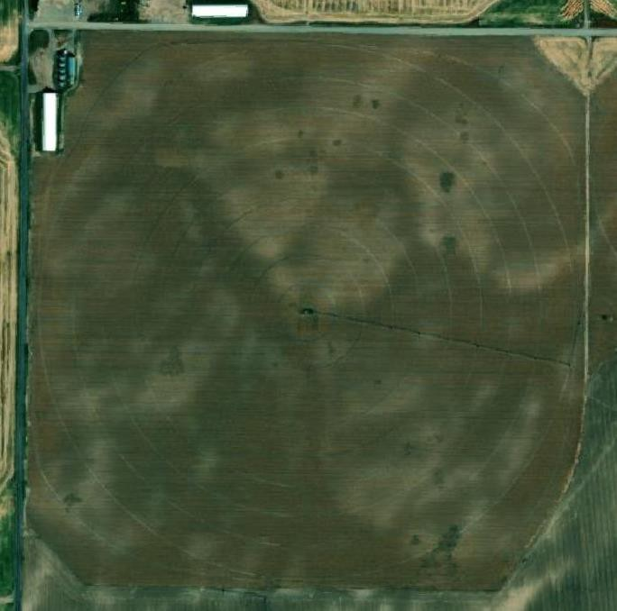
Many potato pest infestations result in disease outbreaks that extract a significant economic toll because of deleterious impacts on crop yield and quality. For example, agronomists constantly try to monitor a growing potato crop for various fungal pathogens that require fungicide treatments once infestations exceed certain observed thresholds (i.e. number of leaves exhibiting symptoms, etc.). Agricultural fields in XXXXX typically exhibit
much subfield variability in terms of the crop vegetation moisture content due to soil and topographical changes across fields. This variability makes it challenging for agronomists to accurately scout and gauge infestation thresholds as fungal needed for accurate recommendations.

Additionally, nitrogen applications are typically conducted by injecting fertilizer products into irrigation systems where the water serves as an efficient carrier to maximize efficiency and nutrient delivery to the plant. Although these practices have resulted in improved economic and environmental sustainability for XXXXX potato cropping systems, the interdependence of irrigation water and nitrogen inputs introduces new challenges given ever-changing dynamics relative to subfield soil and topographical variability and oft occurring inefficient spatial
distributions modern irrigation systems. Figure 1. A basemap image of a typical agricultural field in southern
XXXXX. This field was cultivated to potatoes in 2021.

97

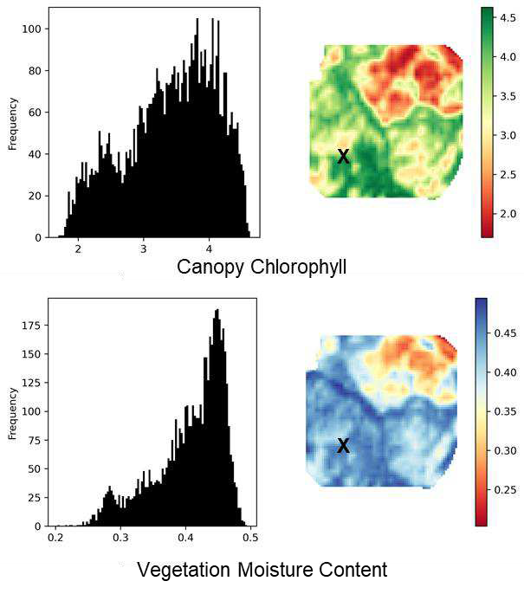
Consider the field in eastern XXXXX shown in Figure 1 cultivated to potatoes in 2021. From the image, it is easy to discern that a center pivot provides the irrigation water and that the center pivot is equipped with a corner armature system that provides additional spatial coverage to the four field corners. These systems are very common in XXXXX given the high cost of agricultural land and the grower's desire to utilize as many cultivated acres as possible to remain profitable. Using publicly available satellite imagery resources, it is possible to measure and visualize the spatial patterns of two metrics driven by in-season nitrogen and irrigation inputs: crop canopy chlorophyll and vegetation water content [2,3].

Figure 2 shows the spatial patterns for both canopy chlorophyll and vegetation water content on July 4, 2021. It is visually apparent that the spatial patterns are similar and likely associated with naturally occurring topographic and soil
variability. At this point in the growing season, tissue and
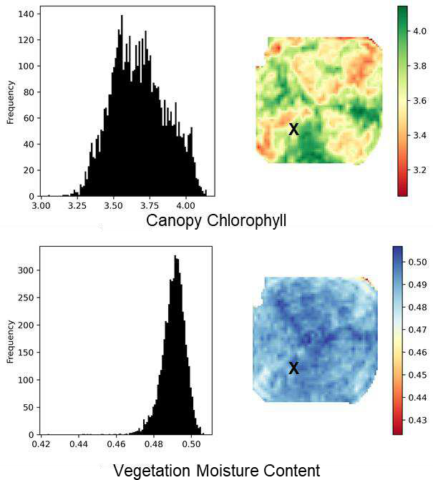
moisture sampling activities are more likely to be spatially correlated (based on subfield

Figure 3. (above) Canopy chlorophyll and vegetation moisture content data derived from remotely sensed satellite imagery collected on July 4, 2021. The spatial patterns and data distributions indicate high correlation between the potato crop canopy chlorophyll

topography and/or soil variability). If tissue samples were collected in the area denoted by “X”, it is possible the data represent an “average” of the field for both nutrient and moisture states. However, when reviewing the spatial patterns approximately 4 weeks later on August 3, 2021 in Figure 3, it is clear that the subfield patterns have changed. The crop canopy chlorophyll patterns now reflect more of a wedge pattern that

Figure 2. (left) Canopy chlorophyll and vegetation moisture content data derived from remotely sensed satellite imagery collected on August 3, 2021. The spatial patterns and data distributions indicate less correlation between the potato crop canopy chlorophyll and moisture content when compared to approximately 4 weeks earlier.

98

indicates reduced crop chlorophyll activity associated with irrigation of the field corners. This is likely due to the increased irrigation water draw when the corner armature is extended that effectively dilutes each water-applied nitrogen application. Conversely, the vegetation moisture content pattern is much more uniform, likely the result of a variable rate drive on the irrigation pump that is capable of increasing water production as demand increases. Now tissue samples and soil moisture observations in the sampling area “X” are more divergent and impacted by multiple types of bias. If the agronomist is not aware of these divergences, their recommendations could be misaligned from actual field needs. This leads to one of two outcomes - over- or under- applications of nitrogen fertilizer leading negatively impacting economic and environmental sustainability outcomes.

References
Kleinkopf, G.E. and D.T. Westermann. 1987. Scheduling nitrogen applications for Russet Burbank potatoes. University of XXXXX Current Information Series, No. 637.
Clevers, J.G., Kooistra, L. and Van den Brande, M.M., 2017. Using Sentinel-2 data for retrieving LAI and leaf and canopy chlorophyll content of a potato crop. Remote Sensing, 9(5), p.405.
Gao, B.C., 1996. NDWI—A normalized difference water index for remote sensing of vegetation liquid water from space. Remote sensing of environment, 58(3), pp.257-266.
PROVIDE A LISTING OF THE OBJECTIVES THAT THIS PROJECT HOPES TO ACHIEVE

The overarching goal of this project is to develop and implement technology-based methods to improve potato crop pest scouting, tissue sampling and soil moisture measurement practices and subsequent data interpretation that drive in-season agronomic recommendations to improve environmental and economic sustainability outcomes. Specifically, a mobile platform will be designed and implemented with trained agronomists that will integrate their field scouting data with advanced imagery analytics focused on potato crop canopy nitrate and moisture content status to enhance potato agronomy decisions. Working with an industrial partner responsible for agronomic recommendations for multiple potato growers in southern XXXXX, the specific objectives will be achieved:

Objective 1 - Identify at least 3 XXXXX potato grower industry partners from which individual potato fields will be tracked for 2 growing seasons.

Objective 2 - Develop a data plan detailing all sources of data, resource needs, acquisition practices, and storage requirements.

Objective 3 - Implement a mobile geospatial digital infrastructure to support data collection and visualization on mobile devices.

Objective 4 - In accordance with the data plan, collect data and maintain documentation on any deviations due to unforeseen circumstances.

99

Objective 5 - Demonstrate technologically integrated set of tools to improve and modernize potato crop pest scouting, tissue sampling and soil moisture data collection and interpretation to industry stakeholders for adoption.

PROJECT BENEFICIARIES

Estimate the number of project beneficiaries: 10-15

Does this project directly benefit socially disadvantaged farmers as defined in the RFA? (Definition of socially disadvantaged farmer: a farmer or rancher who is a member of a socially disadvantaged group. A "Socially Disadvantaged Group" is a group whose members have been subject to discrimination on the basis of race, color, national origin, age, disability, and where applicable, sex, marital status, familial status, parental status, religion, sexual orientation, geneti c information, political beliefs, reprisal, or because all or a part of an individual's income is derived from any public assistance program. .)

Yes ☐ No ☑

Does this project directly benefit beginning farmers as defined in the RFA? (Definition of beginning farmer - an individual or entity who has not operated a farm or ranch for more than 10 years and substantially participates in the operation. )

Yes ☐ No ☑
STATEMENT OF ENHANCING SPECIALTY CROPS

By checking the box to the right, I confirm that this project enhances the competitiveness of ☑
specialty crops in accordance with and defined by the Farm Bill. Further information regarding the definition of a specialty crop can be found at www.ams.usda.gov/services/grants/scbgp.

CONTINUATION PROJECT INFORMATION

Does this project continue the efforts of a previously funded SCBGP project? Yes ☐ No ☑

If you have selected “yes”, please address the following:
DESCRIBE HOW THIS PROJECT WILL DIFFER FROM AND BUILD ON THE PREVIOUS EFFORTS

PROVIDE A SUMMARY (3 TO 5 SENTENCES) OF THE OUTCOMES OF THE PREVIOUS EFFORTS

100

PROVIDE LESSONS LEARNED ON POTENTIAL PROJECT IMPROVEMENTS

What was previously learned from implementing this project, including potential improvements?

How are the lessons learned and improvements being incorporated into the project to make the ongoing project more effective and successful at meeting goals and outcomes?

DESCRIBE THE LIKELIHOOD OF THE PROJECT BECOMING SELF-SUSTAINING AND NOT INDEFINITELY DEPENDENT ON GRANT FUNDS

By working with an industry stakeholder from project inception to implementation we anticipate that this project will become self-sustaining as it becomes demonstrated and adopted amongst growers in southeastern XXXXX.
OTHER SUPPORT FROM FEDERAL OR STATE GRANT PROGRAMS

The SCBGP will not fund duplicative projects. Did you submit this project to a Federal or State grant program other than the SCBGP for funding and/or is a Federal or State grant program other than the SCBGP funding the project currently?
Yes ☐ No ☑

IF YOUR PROJECT IS RECEIVING OR WILL POTENTIALLY RECEIVE FUNDS FROM ANOTHER FEDERAL OR STATE GRANT PROGRAM

Identify the Federal or State grant program(s).

N/A
Describe how the SCBGP project differs from or supplements the other grant program(s) efforts.

N/A

EXTERNAL PROJECT SUPPORT /LETTERS OF SUPPORT
1. Describe the specialty crop stakeholders who support this project and why (other than the applicant and organizations involved in the project).

101

The primary stakeholders for this project are XXXXX potato growers spanning the entire state. In- season pest, nitrogen, and soil moisture scouting and associated data and observations are critical to make informed agronomic decisions impacting both economic and environmental sustainability outcomes. However, technological tools and methods specifically designed for the XXXXX potato industry and tailored to potato crop agronomy needs are vital to modernize these practices. XXXXX potato growers have expressed the need for this research and have expressed support of this project.
Additional stakeholders that will benefit from this proposal are the fresh pack and processing industries that rely on XXXXX potato growers for high yields and quality while minimizing input costs.

EXPECTED MEASURABLE OUTCOMES
SELECT THE APPROPRIATE OUTCOME(S) AND INDICATOR(S)/SUB-INDICATOR(S)

You MUST choose at least one of the seven outcomes listed in the SCBGP Performance Measures, which were approved by the Office of Management and Budget (OMB) to evaluate the performance of the SCBGP on a national level.
OUTCOME MEASURE(S)
Select the outcome measure(s) that are applicable for this project from the listing below. DO NOT change the measures or edit the text.
- Outcome 1: Increasing Consumption and Consumer Purchasing of Specialty Crops
- Outcome 2: Increasing Access to Specialty Crops and Expanding Specialty Crop Production and Distribution
- Outcome 3: Increase Food Safety Knowledge and Processes
- Outcome 4: Improve Pest and Disease Control Processes
- Outcome 5: Develop New Seed Varieties and Specialty Crops
- Outcome 6: Expand Specialty Crop Research and Development
- Outcome 7: Improve Environmental Sustainability of Specialty Crops

OUTCOME INDICATOR(S)
Provide at least one indicator listed in the SCBGP Performance Measures and the related quantifiable result. Cut and poste relevant indicators EXACTLY and then fill in the blanks. If you have multiple outcomes and/or indicators, repeat this for each outcome/indicator. Performance Measures can be found in the “Application Outcome Measures and Indicators” document on the ISDA SCBG website: https://agri.XXXXX.gov/main/marketing/financial- assistance/XXXXX-specialty-crop-block-grant-program/

Outcomes and measures

Outcome 4: Improve Pest and Disease Control Processes
- 4.1 Number of stakeholders that gained knowledge about science-based tools to combat pests and diseases 10 .
- 4.2 Number of stakeholders that adopted pest and disease control best practices, technologies, or innovations 5 .
- 4.5 Total number of producers/processors that enhanced or maintained pest and disease control practices 5 . Of those, the number that reported:

102

  - 4.5a Reduction in product lost to pest and diseases _5 .
  - 4.5d Reduction in pesticide use 5 .

Outcome 7: Improve Environmental Sustainability of Specialty Crops
- 7.1 Number of stakeholders that gained knowledge about environmental sustainability best practices, tools, or technologies 10 .
- 7.2 Number of stakeholders reported with an intent to adopt environmental sustainability best practices, tools, or technologies 5 .
- 7.3 Number of producers that adopted environmental best practices or tools 5 .
- 7.4 Number of new tools/technologies developed or enhanced to improve sustainability/ conservation or other environmental outcomes 3 .
- 7.5 Number of additional acres managed with sustainable practices, tools, or technologies that focused on:
7.5a Water quality/ conservation 1,000 .
MISCELLANEOUS OUTCOME MEASURE
In the unlikely event that the outcomes and indicators above the selected outcomes are not relevant to your project, you must develop a project-specific outcome(s) and indicator(s) which will be subject to approval by AMS. Please consult with ISDA before choosing this outcome measure.

DATA COLLECTION TO REPORT ON OUTCOMES AND INDICATORS
Explain how you will collect the required data to report on the outcome and indicator in the space below.

  - Number of stakeholders that gained knowledge about science-based tools to combat pests and diseases 10
    - For this indicator we plan to present our project annually in January of 2023 and 2024 at the XXXXX Potato Conference that is held at XXXXX State University. We will record the number of attendees and a copy of the formal attendance record.

  - Number of stakeholders that adopted pest and disease control best practices, technologies, or innovations 5 .
    - For this indicator our stakeholder partner is driving the need for the tool we are providing and already plans to adopt it across the thousands of acres he manages. He is planning to recruit 4 additional growers from his network to trail testing the application during the project for long term adoption.
  - Total number of producers/processors that enhanced or maintained pest and disease control practices 5 . Of those, the number that reported:
    - 4.5a Reduction in product lost to pest and diseases _5 .
    - 4.5d Reduction in pesticide use 5 .
For this measure in year 2 we plan to record at 5 grower fields the results from Year 1 (based on data recorded from the student data collection) and compare to improvements in Year 2 based on

103

decisions informed by our data collection and analysis. This includes pest reduction counts and reduced pesticide usage based on our app recommendations.

Outcome 7: Improve Environmental Sustainability of Specialty Crops
- 7.1 Number of stakeholders that gained knowledge about environmental sustainability best practices, tools, or technologies 10.
We plan to present our results at the annual potato growers conference

- 7.2 Number of stakeholders reported with an intent to adopt environmental sustainability best practices, tools, or technologies 5 .
For this indicator our stakeholder partner is driving the need for the tool we are providing and already plans to adopt it across the thousands of acres he manages. He is planning to recruit 4 additional growers from his network to trail testing the application during the project for long term adoption.
- 7.3 Number of producers that adopted environmental best practices or tools 5 .
For this indicator our stakeholder partner is driving the need for the tool we are providing and already plans to adopt it across the thousands of acres he manages. He is planning to recruit 4 additional growers from his network to trail testing the application during the project for long term adoption.

- 7.4 Number of new tools/technologies developed or enhanced to improve sustainability/ conservation or other environmental outcomes 3 .
Our plan is to create 3 key decision support tools for our app
- 7.5 Number of additional acres managed with sustainable practices, tools, or technologies that focused on:
7.5a Water quality/ conservation 1,000 .
We will be sampling and surveying across a minimum of 1000 acres.

BUDGET NARRATIVE *ALSO ATTACH EXHIBIT B – LINE ITEM BUDGET
All expenses described in this Budget Narrative must be associated with expenses that will be covered by the SCBGP. Applicants should review the Application Guidelines Appendix A section 4.7.2 Allowable and Unallowable Costs and Activities prior to developing their budget narrative.

Budget Summary
Expense Category | Funds Requested
Personnel | 88,528
Fringe Benefits | 4,657
Travel | 2,527.20
Equipment | 7000
Supplies
Contractual | 25,000
Other | 2,700
Total Budget | $130,412.20

104

PERSONNEL
List any of the organization’s employees whose time and effort will be specifically identified and easily and accurately traced to project activities that enhance the competitiveness of specialty crops. See the Request for Applications section 4.7.2 Allowable and Unallowable Costs and Activities for further guidance.

# | Name/Title | Level of Effort (# of  hours OR % FTE) | Funds  Requested
1 | XXX Faculty | 1 month summer salary  (4 wks at 40hrs/wk) x 2 years | 20,314
2 | XXX PhD Student | 12 weeks summer 40 hr/wk full time, 32 weeks semester stipendat 19.5 hrs/wk x  2 years | 50,550
3 | Undergraduate student | 12 weeks at 40 hrs/wk x  2 years | 17,664
4
88,528
Personnel Subtotal
PERSONNEL JUSTIFICATION

For each individual listed in the above table, describe the activities to be completed by name/title including approximately when
activities will occur. Add more personnel by copying and pasting the existing listing or deleting personnel that aren’t necessary.
Personnel 1: XXX Faculty (XXXXX): supervision and project management, workflow and sampling planning, report writing, mobile app design, SOP generation for data collection, and satellite image analysis and coding overview. Project planning to meet industry partner needs.

Personnel 2: XXX PhD Student (XXXXX): programming and app development, integration of tools in to data collections and field assessment, training and supervision of student intern, liaison with industry stakeholder, sample and image processing integration.

Personnel 3: XXX Undergraduate Student: data collection and field surveys, communication with team members and stakeholder, data gathering and field testing of application.

Add other Personnel as necessary

FRINGE BENEFITS
Provide the fringe benefit rates for each of the project’s salaried employees described in the Personnel section that will be paid with
SCBGP funds.

# | Name/Title | Fringe Benefit Rate | Funds Requested
1 | XXX Faculty | 10.5% (summer fringe rate) | 2,133
2 | XXX PhD Student | 3.7% | 1,870
3 | Undergraduate student | 3.7% | 654
4

105

4,657
Fringe Subtotal
TRAVEL
Explain the purpose of each Trip Request. Please note that travel costs are limited. In the case of air travel, project participants must use the lowest reasonable commercial airfares. Travel expenses must comply with the State of XXXXX travel regulations found at www.sco.XXXXX.gov .

# | Trip Destination | Type of Expense (airfare, car rental, hotel, meals, mileage,  etc.) | Unit of Measure (days, nights, miles) | # of Units | Cost per Unit | # of Travelers Claiming the Expense | Funds Requested
1 | XXXXX farming area – student to collect plant tissues and pest samples over 12 weeks during the growing season | mileage | 2-3 x weekly 60 mile roundtrips to various fields in IF area during growing season x 2  years | 4320 | .585 | 1 | 2527.20
2
3
4
5
6
7
2,527.20
Travel Subtotal
TRAVEL JUSTIFICATION

For each trip listed in the above table describe the purpose of this trip and how it will achieve the objectives and outcomes of the project. Be sure to include approximately when the trip will occur. Add more trips by copying and pasting the existing listing or delete trips that aren’t necessary.
Trip 1 (Approximate Date of Summer/2023): 2-3 x weekly 60 mile roundtrips to various fields in IF area during growing season for tissue sampling, pest assessment and crop health review

Trip 2(Approximate Date of Summer/2024): 2-3 x weekly 60 mile roundtrips to various fields in IF area during growing season for tissue sampling, pest assessment and crop health review

CONFORMING WITH YOUR TRAVEL POLICY

By checking the box to the right, I confirm that my organization will adhere to the State of XXXXX ☑
travel regulations at www.sco.XXXXX.gov

EQUIPMENT
106

Describe any special purpose equipment to be purchased or rented under the grant. ‘‘Special purpose equipment’’ is tangible, nonexpendable, personal property having a useful life of more than one year and an acquisition cost that equals or exceeds $5,000 per unit and is used only for research, medical, scientific, or other technical activities. See the Application Guidelines Appendix A section
    - Allowable and Unallowable Costs and Activities, Equipment - Special Purpose for further guidance
Rental of "general purpose equipment’’ must also be described in this section. Purchase of general purpose equipment is not allowable under this grant. See Application Guidelines Appendix A section 4.7.2 Allowable and Unallowable Costs and Activities, Equipment - General Purpose for definition, and Rental or Lease Costs of Buildings, Vehicles, Land and Equipment.

# | Item Description | Rental or Purchase | Acquire When? | Funds Requested
1 | N/A
2
3
4
Equipment Subtotal
EQUIPMENT JUSTIFICATION

For each Equipment item listed in the above table describe how this equipment will be used to achieve the objectives and outcomes of
the project. Add more equipment by copying and pasting the existing listing or delete equipment that isn’t necessary.
Equipment 1:

Equipment 2:

Equipment 3:

Add other Equipment as necessary

SUPPLIES
List the materials, supplies, and fabricated parts costing less than $5,000 per unit and describe how they will support the purpose and goal of the proposal and enhance the competitiveness of specialty crops. See Application Guidelines Appendix A section 4.7.2 Allowable and Unallowable Costs and Activities, Supplies and Materials, Including Costs of Computing Devices for further information.

Item Description | Per-Unit Cost | # of Units/Pieces Purchased | Acquire When? | Funds Requested
Soil moisture monitor | $1000 | 2 | Spring 2023 | 2,000
Tablets | $500 | 4 | Fall 2023 | 2,000
Cloud Repository Storage | $500/yr | 1 | Fall 2022 | 500
Tablets | $500 | 4 | Spring 2024 | 2,000
Cloud Repository Storage | $500 | 1 | Fall 2023 | 500
7000
Supplies Subtotal
SUPPLIES JUSTIFICATION

107

Describe the purpose of each supply listed in the table above purchased and how it is necessary for the completion of the project’s objective(s) and outcome(s).

Soil moisture monitors x 2 – soil monitors to place to candidate fields to monitor soil moisture conditions. These sensors can be moved between and within fields and will aid researchers in determining variable moisture conditions in a field setting to compare with remotely sensed imagery
Tablets x 8 – Mobile tablets will be provided to stakeholder partners and student intern to collect field based information to feed in to app development and programming in inform sustainable decision making.
Cloud Repository Storage – for quick and efficient data storage and access to sampling results, cloud storage will be required. In addition, this will act to guide sampling protocols and greater ability to share data across mobile devices and improve decision making

CONTRACTUAL/CONSULTANT
Contractual/consultant costs are the expenses associated with purchasing goods and/or procuring services performed by an individual or organization other than the applicant in the form of a procurement relationship. If there is more than one contractor or consultant, each must be described separately. (Repeat this section for each contract/consultant.)
ITEMIZED CONTRACTOR( S)/CONSULTANT(S)
Provide a list of contractors/consultants, detailing out the name, hourly/flat rate, and overall cost of the services performed. For pass- through entities, provide an itemized budget (personnel, fringe, travel, equipment, supplies, other, etc.) with appropriate justification.

# | Name/Organization | Hourly Rate/Flat Rate | Funds Requested
1 | XXXXX Crop Improvement Association – Leaf tissue sampling at $75 per petiole | $75 per petiole or 200 plant samples in year 1 | 15,000
2 | XXXXX Crop Improvement Association – Leaf tissue sampling at $75 per petiole | $75.18 per petiole or 133 plant samples in year 2 | 10,000
3
4
25,000
Contractual/Consultant Subtotal

CONTRACTUAL JUSTIFICATION
Provide for each of your real or anticipated contractors listed above a description of the project activities each will accomplish to meet the objectives and outcomes of the project. Each section should also include a justification for why contractual/consultant services are to be used to meet the anticipated outcomes and objectives. Include timelines for each activity. If contractor employee and consultant hourly rates of pay exceed the salary of a GS-15 step 10 Federal employee in your area, provide a justification for the expenses. This limit does not include fringe benefits, travel, indirect costs, or other expenses.. See Application Guidelines Appendix A section 4.7.2 Allowable and Unallowable Costs and Activities, Contractual and Consultant Costs for acceptable justifications. Contracts must also conform to State of XXXXX procurement standards. That information can be found at https://purchasing.XXXXX.gov/

108

Contractor/Consultant 1: XXXXX Crop tissue sampling for potato plant leaf samples – will inform our decision making app on the variable rate of plant health across a field for targeted assessment to improve nutrients, water, pesticide and other applications.
Contractor/Consultant 2:

Contractor/Consultant 3:

Add other Contractors/Consultants as necessary

CONFORMING WITH YOUR PROCUREMENT STANDARDS

By checking the box to the right, I confirm that my organization followed the same policies and procedures ☑
used for procurements from non-federal sources, which reflect applicable State and local laws and regulations and conform to the Federal laws and standards identified in 2 CFR Part 200.317 through.326, as applicable. If the contractor(s)/consultant(s) are not already selected, my organization will follow the same requirements.

See XXXXX specific procurement standards at https://purchasing.XXXXX.gov/

OTHER
Include any expenses not covered in any of the previous budget categories. Be sure to break down costs into cost/unit. Expenses in this section include, but are not limited to, meetings and conferences, communications, rental expenses, advertisements, publication costs, and data collection.
If you budget meal costs for reasons other than meals associated with travel per diem, provide an adequate justification to support that these costs are not entertainment costs. See Request for Applications section 4.7.2 Allowable and Unallowable Costs and Activities, Meals for further guidance.

Item Description | Per-Unit Cost | Number of Units | Acquire When? | Funds Requested
Publication fees | 2,700 | 1 | Sept 2024 | 2,700
2,700
Other Subtotal
OTHER JUSTIFICATION

109

Describe the purpose of each item listed in the table above purchased and how it is necessary for the completion of the project’s
objective(s) and outcome(s).

For wide dissemination of project results across the scientific community we plan to publish our work in an open source journal.

For information dissemination across the grower community we plan to present and demonstrate our results at the yearly Potato School Conference held at XXXXX State University (no charge or travel fees required)

PROGRAM INCOME
Program income is gross income—earned by a recipient or subrecipient under a grant—directly generated by the grant-supported activity, or earned only because of the grant agreement during the grant period of performance. Program income includes, but is not limited to, income from fees for services performed; the sale of commodities or items fabricated under an award (this includes items sold at cost if the cost of producing the item was funded in whole or partially with grant funds); registration fees for conferences, etc.

Source/Nature of Program Income | Description of how you will reinvest the program income into the project to solely  enhance the competitiveness of specialty crops | Estimated Income
N/A
Program Income Total

110

