LIVESTOCK CARCASS COMPOSTING BEST PRACTICES
Composting of livestock carcasses is a biological process in which naturally occurring microorganisms convert organic materials into a soil-like material called compost. More specifically, mortality composting can be described as the above ground burial of dead stock in a mound of combined plant material (like sawdust or shavings) and manure. Sufficient supplemental carbon is required around the carcass to absorb bodily fluids and prevent odors from escaping the mound.
Mortality composting is generally conducted in 3 stages. In the first stage of composting, the pile is left undisturbed as soft tissue decomposes and bones partially soften. The compost is usually moved, turned, or mixed to begin the second stage, during which time the remaining materials break down further. Following completion of the second stage, the final composting process is completed with the curing/storage phase. The result can be a high-quality compost that can be sold or utilized on-site. Small fragments of bone might still be present in the final product, which can be sifted or highlighted as part of the natural process.
Select An Appropriate Composting Site
The site should be located in an area with low soil permeability and be protected from run-on/run-off precipitation.
Additional considerations:
- Functional compost piles will not have leachate or effluent around the base.
- Construct piles and windrows to run in parallel with the land’s slope.
- The water table at the site should be at least 6ft below the surface.
- The site should not be located within a 100-year floodplain.
- The site should not be within 300ft of surface water (canals, rivers, streams, wells).
- Run-off from the composting facility during a heavy rainfall event should be directed to an effluent pond.
- Well-functioning compost piles should have minimal odor. However, consideration should be given to prevailing winds and proximity to neighbors in order to prevent potential odor problems.
- Actions should be taken to shield composting site from public view

Step-By-Step Carcass Composting
Construction of the pile requires large quantities of a carbon material, such as manure. A minimum of 13-16 cubic yards is recommended to establish a composting pile for a 1000 lb carcass: approximately 12 feet wide by 6 feet tall, with length depending on the animal(s).

The following process for conducting a mortality composting pile are recommended:
Step 1: Establish a 5-12” deep base layer of relatively dry carbon material such as wood chips or yard trimmings. The width of the base layer should be wide enough to accommodate the carcass with a minimum 24" of space. The depth of the layer should range from no less than 18” for small carcasses and 24” for large carcasses.
Step 2: Cover the carcass with a combination of manure/bedding to a depth of 24” or greater. The material used to cover the animal should be damp to enhance the composting process. The material should feel moist but not be too wet. Composting material should be considered too wet when water can be squeezed from it.
Step 3: Leave pile undisturbed for a minimum of 4 months (in ideal conditions, a 1000# carcass can be fully composted in 4 weeks). Now that the carcass is properly enveloped, the process of composting takes 4-12 months depending on the size and mixture. Throughout this period, the pile should be monitored regularly, adding more cover when necessary. During this time, microbial activity from bacteria and fungi are reducing/decomposing the carcass and tissue to a homogenous organic material.
Step 4: When the soft tissue has completely decomposed (4-6 weeks) the pile can be turned to complete the composting process. This will likely result in a second heating process.
Step 5: Leave it to cure for a minimum of 4 weeks before harvesting the compost.
Additional Note: Although the composting process is complete, fragments of large bones of adult cattle may still be present, but the bones should be free of soft tissue and harmful pathogens.
Monitoring Process
- Composting temperatures should be monitored weekly from several points at depths of 1 ft and 3 ft. Multiple sites within the pile should be marked and used for daily readings.
- The heat required for the inactivation of pathogens is a function of both temperature and length of time. Temperatures must reach 132-145ºF (55-65ºC) for approximately 3 days or 110 ºF for 10 days to sufficiently kill most pathogens. To achieve an effective pathogen kill, all materials in the compost pile must be exposed to high temperatures for prolonged periods.
- Visit the composting rows frequently to ensure there is no odor or liquid leaking from the pile. Add more carbon material or manure, if needed, to cover the carcass(es).
- After several days of high temperatures (131- 145 ºF), check for remaining soft tissue. If none, the pile can be turned as described above.
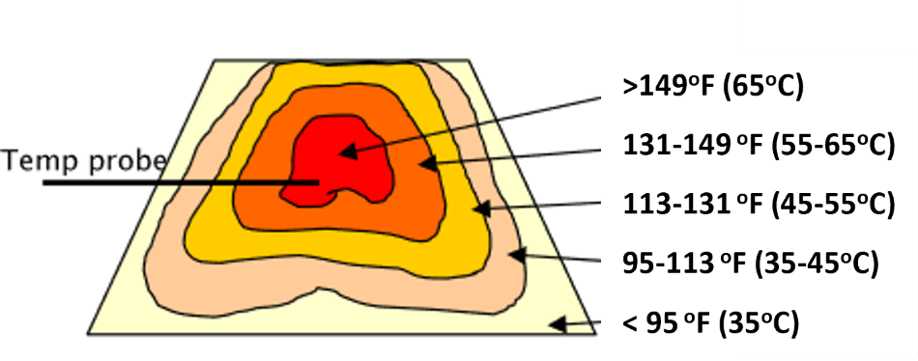
Health and Safety
A compost pile contains living microorganisms including molds, bacteria, fungi and protozoa. These microorganisms can cause adverse reactions, particularly in people with a weakened immune system. The following precautions should be followed when handling dead stock or compost materials.
- Wear gloves
- Wash hand after handling
- Avoid breathing dusts or mists created by the composting process
- Wash work clothing regularly

