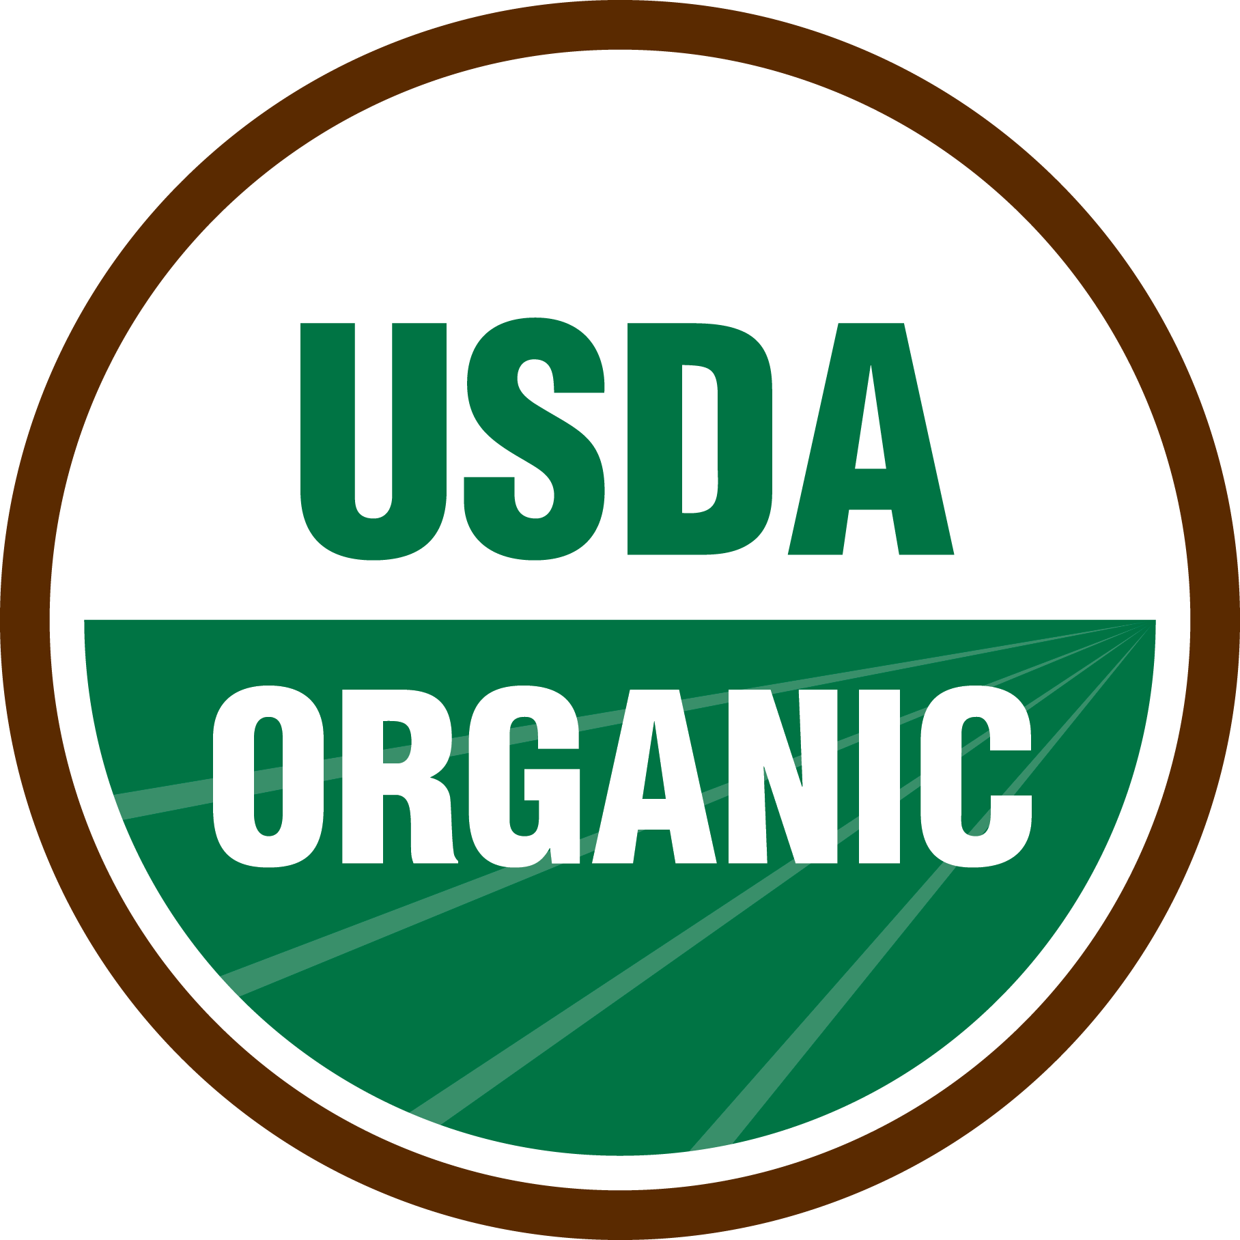
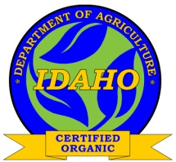
ISDA Private Label Arrangement Form

The National Organic Program allows for “Private Label” arrangements on organic labels and packaging. Approval for these situations and instruction to accredited certification agents and certified entities can be found in the NOP Handbook, section G, Policy Memos, “PM 11-7; 10/31/2011."

A private label arrangement arises when an ISDA certified operation wishes to use labeling or packaging for organic products that does not include their name (the name of the ISDA certified entity) and the name of another “distributor” is used. The distributor who is listed on the label may or may not be certified themselves.

Regardless of the certification status of the named distributor, the ISDA must review and approve any (and all) labels / printed packaging used for organic products by our certified clients. Along with copies of the labels, the ISDA certified operation must submit a completed Private Label Affirmation Form for each private label arrangement. The Private Label Company representative must sign and date this form.

ISDA Certified Entity:
Company Name:
Mailing Address:
Name of Organic Manager:
Primary Phone:

Private Label Company (manufacturer or packer):
Company Name:
Mailing Address:
Physical Address (if different):
Name of Organic Manager:
Primary Phone:
Cell Phone:
e-mail address:

Is the Private Label Company certified for organic production or handling: YES NO

If YES, provide information on certification:

Name of Certification Agent Cert. or Client Number

Listing of Labels / Products

In the chart below, provide information for each label to be used under the Private Label agreement. For products with multiple sizes / weights / counts, if the ONLY difference on the entire label or package is the size / weight / count, then only one example has to be submitted. Labels using the USDA logo that will be printed in color must be submitted in color for review.

Product Name  (as appearing on ISDA certificate addendum) | Label Description  (name of product as it appears on PDP – include wt., count, or size) | Level of Claim  (100% Organic, Organic, or Made With *** Organic)

On the labels listed above, ISDA is identified as the Accredited Certification Agent (i.e. labels state “certified organic by ISDA”): TRUE FALSE

If FALSE, who is listed as the certification agent?* Please provide proof of organic certification with that Certification Agent

Name of Certification Agent:

Contact Person:

Who is responsible for designing the labels? __ISDA Distributor __ Handler/Packer
Who is responsible for printing the labels? __ISDA Distributor __ Handler/Packer
Who is responsible for the inventory of labels? __ISDA Distributor __ Handler/Packer

THIS NEXT QUESTION MUST BE ANSWERED BY THE PRIVATE LABEL COMPANY

The labels identified above are exclusively used by the ISDA certified operation who is labeling organic products for us (i.e. no other entity uses / packs products into the labels listed above) TRUE * FALSE

* The National Organic Program expects the certification agent listed on the label to be able to address any inquiries about the product, by a consumer or other interested party. For that reason, for any labels with ISDA listed as the certification agent, the above must be completed by the Private Label Company and must be TRUE.
Affirmation and Signatures

I affirm that I am an authorized representative of the distributor / private label company identified above. The information on this form and associated attachments is complete and accurate to the best of my knowledge. Labels listing ISDA as the agent will be used exclusively on product made or packaged at the ISDA certified facility named above. Any changes to the labels listed above will be submitted to the ISDA Certified Operation whenever such changes are made. I understand that NOP regulations require ISDA to give final approval for all labels used by their clients, even when another certifier may be listed on the label.

I agree to cooperate with ISDA and/or the certified handler in determination of formulation and label compliance to the USDA NOP standard. This may include but not be limited to: verification of ingredients, organic certification of other handlers that interact with the product(s) or ingredients, submittal of organic product profiles, or submittal of documentation to demonstrate the percentage of organic ingredients contained in the labeled product.

Furthermore, I understand that these products will be listed on the organic certificate and/or certificate addendum for the ISDA certified company listed above. I also understand that Per NOP regulation, organic certificates cannot be withheld from public disclosure, and ISDA or the ISDA certified company listed above is required to provide that certificate in the event of request or inquiry.

By signing this document I acknowledge that withholding information or providing false information may result in the removal of the product(s) requested from the organic certificate. Subsequent marketing of these products as organic would constitute a violation of the National Organic Program standards and may result in criminal or civil penalties.

Private Label Representative’s Name (please print) Title Date

Signature Private Label Representative

